**MULTINOMIAL RIGRESSION**

**Business Problem** = ﻿ ﻿﻿Prepare a prediction model predict to the type of program a student is in based on other attributes

* **Name of the File: -** mdata.csv
* **Size of the File: -** 12 KB
* **Data: -** 200 Observation, 10 Variable

**Exploratory data Analysis** =

* **Outliers: -**  Outliers are not presents.
* **Missing Value: -** Data don’t have Missing Values
* **Normality: -** Data are not normal
* **Output:** - 3 Different values

1. Quantity of different output values

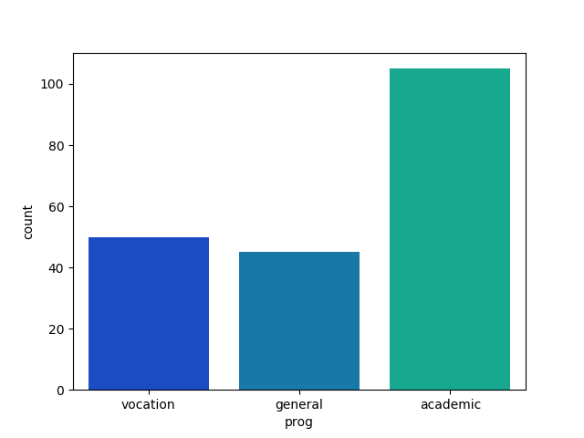**Vocation** - 50

**General** - 45

**Academic** - 105

**Model Building on Train Data = ﻿**Building model by considering academic as base.

* **Summary: -**

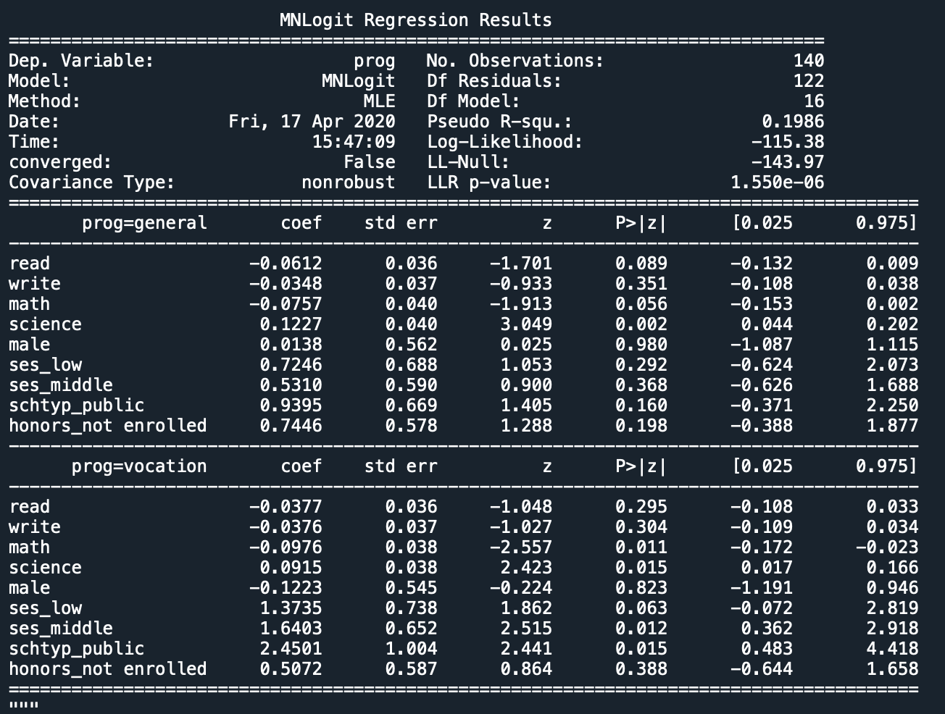

* **AIC: -** ﻿267
* **﻿Accuracy of train :-** 64 %
* **Accuracy of test :-** 55 %
* **No observation: -** 140
* **﻿Df Residuals:** - 122

**Python code file**: - [Multinomial Analysis.py](https://github.com/nilaydeshmukh0/Multinomial-Logistic-Regression/blob/master/Multinomial%20Analysis/Multinomial%20Analysis.py)